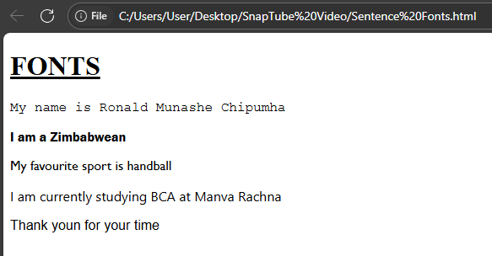
<!DOCTYPE html>
<html>
<head><title>Sentence Fonts</title></head>
<body>
<h1><u>FONTS</u></h1>
<p style="font-family: 'Courier New', Courier, monospace;">My name is Ronald Munashe Chipumha</p>
<p style="font-family: 'Franklin Gothic Medium', 'Arial Narrow', Arial, sans-serif;">I am a Zimbabwean</p>
<p style="font-family: 'Gill Sans', 'Gill Sans MT', Calibri, 'Trebuchet MS', sans-serif;">My favourite sport is handball</p>
<p style="font-family: 'Segoe UI', Tahoma, Geneva, Verdana, sans-serif;">I am currently studying BCA at Manva Rachna</p>
<p style="font-family: Arial, Helvetica, sans-serif;">Thank youn for your time</p>
</body>
</html>

